**GEOCHEMISTRY AND HYDROTHERMAL ALTERATION AT THE MOUNT RAWDON GOLD DEPOSIT**

**Ned Howard**

Evolution Mining Limited, Lvl3/1 Altona Street, West Perth, WA 6005

**Key Words**: gold, multi-element geochemistry, hydrothermal alteration, spectroscopy, ASD, pathfinder elements, major elements, epithermal, intrusion-related.

**Abstract**

The Mount Rawdon gold deposit is located ~75 km southwest of Bundaberg, Queensland, Australia. Past production from the deposit was 45.6 Mt at 1.03 g/t Au for 1.35 Moz to December 2014, while resources total 50.7 Mt at 0.71 g/t Au for 1.16 Moz, giving a total endowment of 2.51 Moz.

Mount Rawdon is hosted within the Triassic Aranbanga Volcanics to the north of the interpreted ENE-trending Swindon Fault and east of the regional NNW-trending Mt Perry Fault. The Aranbanga Volcanics consist predominantly of felsic volcanoclastic breccias intruded by pre-mineral rhyodacite stocks and dykes and a series of late- to post-mineral andesitic to rhyolitic dykes.

A program of multi-element geochemistry and hyperspectral analysis at Mt Rawdon has helped to better constrain the host geology and has provided valuable insights into geochemical and alteration mineral zonation at the deposit, potentially of great use to explorers.

Sericite, chlorite and carbonate are almost ubiquitous alteration minerals throughout the deposit and define a moderately southwest dipping pipe-like zone of alteration through felsic volcaniclastic breccias and a rhyodacitic stock and hosts gold mineralisation. Deeper parts of the alteration pipe are defined by K addition and Na removal consistent with moderate to strong sericite alteration, elevated Te, Bi and S and possible actinolite associated with ore-stage pyrite. Intermediate levels show variable K and Na addition, consistent with variable sericite-alkali feldspar alteration and elevated Bi (+ Te, Cu, Ag) in association with gold. The upper parts of the deposit show K addition and Na depletion suggestive of phengitic sericite ± K-feldspar with elevated Ag, As, Cu, Pb (+ Bi) in association with gold. Marginal to the main alteration pipe, variable Na addition is suggestive of albite alteration associated with a pathfinder element assemblage of Mn, Zn, Pb and As.

Hyperspectral analysis has shown that white micas in the deposit are compositionally zoned from proximal phengitic muscovite (SWIR Al-OH absorption feature wavelength, wAlOH > 2207nm) to marginal muscovite (wAlOH <2205nm). Sericite crystallinity is high within the deposit (Sericite Crystallinity Index, SCI > 2) and decreases gradually away from the main alteration pipe, to SCI < 1.75 greater than 200m from the ore zone.

Gradients in pathfinder elements, sericite crystallinity and sericite composition support previous fluid inclusion evidence for a combination of temperature decrease, boiling and mixing as potential depositional mechanisms for gold relatively deep in the epithermal environment. Exploration for other Mt Rawdon-style gold deposits should focus on recognition of areas where the upper parts of the hydrothermal system have likely been preserved at or immediately below surface. These should manifest as zones of sericite-chlorite-carbonate ± K-feldspar alteration where sericite is zoned inwards from muscovite to phengitic muscovite with moderate to high crystallinity (SCI > 1.75) in association with Ag, As, Zn, Pb, Cu and Mn, but lacking significant Te.

**Geological Setting**

Mount Rawdon is situated ~75km southwest of Bundaberg, Queensland, where it is hosted within the Triassic Aranbanga Volcanics of the Esk Basin province. The Aranbanga Volcanics consist predominantly of rhyolitic to dacitic volcanic and volcaniclastic rocks with minor basalt at their base, and overlie Palaeozoic sediments of the Curtis Island Group Coastal Subprovince, Wandilla Province. The regional scale NNW-trending Perry Fault and ENE-trending Swindon Fault appear to exert a significant control on the distribution of rock units in the area, particularly the Aranbanga Volcanics. Mount Rawdon gold deposit occurs at the southeastern margin of an area of outcropping Aranbanga Volcanics near the east-northeastern termination of the Swindon Fault.

The Aranbanga Volcanics have been dated at ~220-230 Ma (Donchak, et al, 2013 and references therein), broadly synchronous with the Hogsback Granite (228 ± 4 Ma from K-Ar on biotite; Cranfield & Murray, 1989), an I-type biotite-hornblende granodiorite outcropping to the north of Mount Rawdon, and with the Mount Rawdon deposit itself (~233 Ma from K-Ar on sericite; Perkins, 1995). The volcanics, and thus the Mt Rawdon gold deposit, are thought to have formed during a period of extension at the end of the Hunter-Bowen Orogen associated with the formation of the Esk Trough (Donchak et al, 2013).

**Local Geology**

The Mount Rawdon gold deposit is hosted within a sequence of massive to diffusely bedded polymictic volcaniclastic breccias and conglomerates with minor bedded tuffaceous intervals (Figure 1). The sequence is dominantly rhyodacitic to dacitic in composition with minor units of andesitic bulk composition. The genesis of the volcaniclastic sequence has been debated, with previous interpretations ranging from a bedded sequence of pumiceous breccias and minor andesitic lavas (Harris, 2010) to a diatreme breccia complex (Brooker and Jaireth, 1995).

The felsic volcaniclastic rocks are intruded by a N-S oriented elongate stock, the rhyodacitic Eastern Dacite, and compositionally similar dykes. The Western Dacite is another N-S oriented elongate stock of dacitic composition to the west of the Mt Rawdon gold deposit that does not breach the current land surface. Most gold is hosted within the felsic volcaniclastic rocks, Eastern Dacite and associated dykes. The Western Dacite is cut by gold-bearing veinlets and alteration, but does not host any economic gold resources.

Numerous stages of late syn- to post-mineral rhyolitic and andesitic dykes cross-cut the deposit, lack significant gold and are affected by only low temperature alteration assemblages. Most rhyolite dykes dip shallowly towards the north, the most notable being a prominent quartz-K feldspar-biotite porphyry dyke (QFBP). Contrary to previous petrographic classification of dyke stages as alkalic (trachyte and trachyandesite), whole rock geochemistry suggests sub-alkalic (medium- to high-K calc-alkalic) composition for dykes and preceding volcanic rocks.

Numerous faults cross-cut the deposit, including steeply to moderately dipping, N-S striking faults and NW-SE and NE-SW striking faults. Most show predominantly post-mineral normal displacement likely due to multiple slip events between intrusion of post-mineral dykes (Standing, 2014).

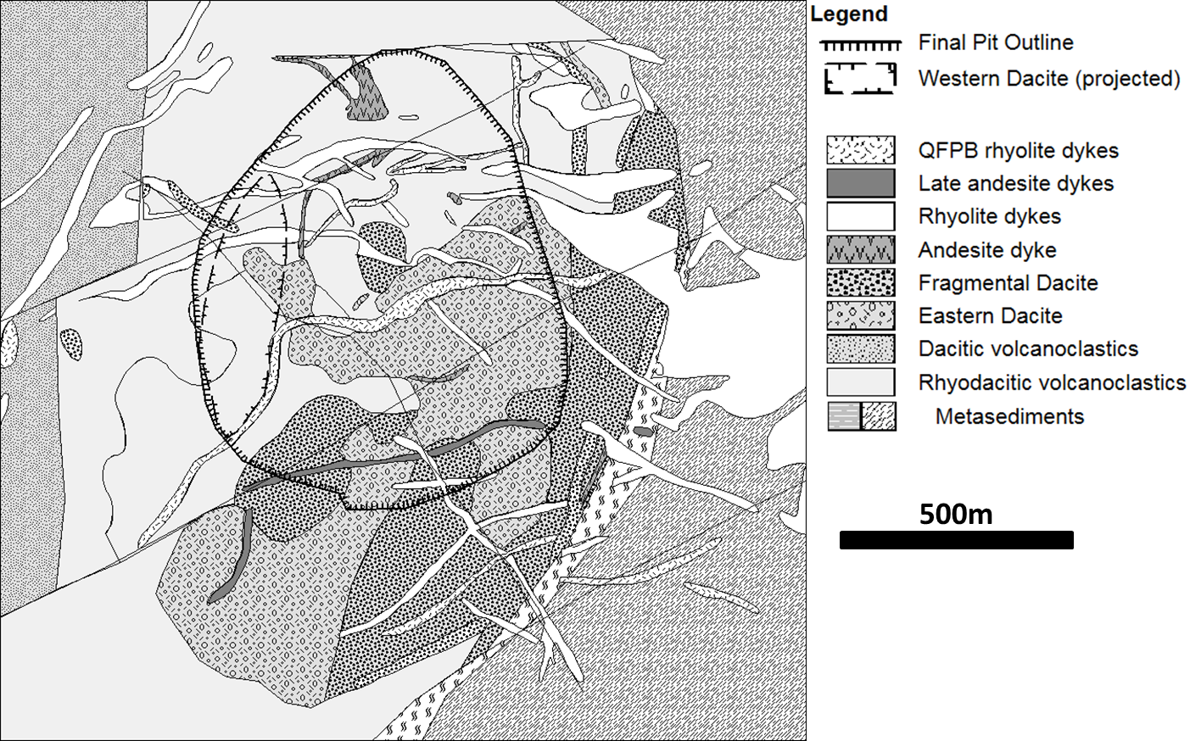

***Figure 1:*** *Local geology of the Mount Rawdon gold deposit (from Dugdale, 2014).*

**Alteration and Gold Mineralisation**

Sericite, chlorite and carbonate are almost ubiquitous alteration minerals throughout the deposit and define a moderately southwest dipping pipe-like zone of alteration that hosts gold mineralisation. This pipe dips towards the Western Dacite, and traverses both volcaniclastic breccias and the Eastern Dacite. Brooker and Jaireth (1995) defined zones of distal to proximal propylitic, phyllic, sericitic, silica-pyrite and chloritic alteration. Propylitic (chlorite-calcite ± epidote ± illite ± pyrite) and phyllic (white mica-quartz-pyrite) define broad alteration zones, possibly related partially to pre-mineral intrusive events. Sericitic alteration (white mica-quartz-pyrite ± ankerite ± chlorite) forms a broad zone associated with gold mineralisation, while silica-pyrite (quartz ± feldspar-pyrite) and clots and veinlets of chloritic alteration (chlorite-carbonate-epidote-actinolite-sulphides) host gold. Harris (2010) noted increasing actinolite in association with ore stage pyrite with increasing depth in the deposit. Late rhyolitic dykes are weakly to moderately illite-smectite ± kaolinite altered, while late andesitic dykes display weak to moderate chlorite-illite-smectite alteration.

Gold occurs in association with sulphide veinlets, disseminations and clots accompanied by chloritic and silica-pyrite alteration assemblages. Veinlets may contain pyrite, iron-bearing carbonates, base metal sulphides, sulphosalts, bismuth, hessite and gold, but rarely quartz (Brooker & Jaireth, 1995). High grade gold intercepts (>10 g/t Au) map out a mesh of moderately SW dipping trends, shallow NNW dipping trends and a steep southerly plunge associated with a flexure in the western contact of the Eastern Dacite. These trends probably represent fluid pathways at the time of mineralisation. Southwest dipping trends, in particular, are coincident with trends in alteration geochemistry and offsets or flexures on the contact of the Eastern Dacite, suggesting that they represent syn-mineral faults.

**Spectral Mineral Zonation**

A program of short wave infrared (SWIR) hyperspectral analysis using an ASD Terraspec 4 Hi-Res has provided valuable insights into alteration mineral zonation at Mount Rawdon, potentially of great use to explorers. Patterns are evident in sericite (white mica and illite) and chlorite that likely reflect changes in temperature and pH of formation of the alteration assemblage.

The composition of sericite can be determined from SWIR spectra using the wavelength of the Al-OH absorption feature at ~2200nm (wAlOH; e.g. Scott & Yang, 1997). Hyperspectral analysis has shown that white micas in the deposit are compositionally zoned from proximal phengitic muscovite (wAlOH > 2207nm) to marginal muscovite (wAlOH < 2205nm; Figure 2). Phengitic white mica typically forms under near-neutral conditions, while muscovitic white mica tends to form under weakly acidic conditions (Halley, 2007), suggesting a slight decrease in pH from the core to margin of the deposit. In the upper parts of the Mount Rawdon deposit, white mica becomes increasingly phengitic (>2210nm), suggesting an increase in pH towards the top of the system.

Sericite crystallinity, determined by the ratio of the depth of the Al-OH absorption feature to the depth of the ~1900nm water/hydroxyl absorption feature, is high within the deposit (sericite crystallinity index, SCI > 2), indicative of 2M white mica and temperatures of formation ≥300oC (Figure 3). The SCI decreasing gradually away from the main alteration pipe to be < 1.75 greater than 200m from the ore zone. Unmineralised areas of high sericite crystallinity in the felsic volcaniclastic package to the north of the deposit may reflect white mica in phyllic alteration thought to be associated with an earlier hydrothermal event/s.

Chlorite composition can be determined approximately from the wavelength of the Fe-OH absorption feature (wFeOH) at ~2250nm, which ranges from ~2260nm (Fe-rich) to 2240nm (Mg-rich) (Pontual et al, 1997). While lithology shows a control on the wFeOH (more mafic units have shorter wavelength, more Mg-rich chlorite), a pattern is apparent of increasing wFeOH from <2253nm in the deeper, central parts of the deposit to wavelengths >2256nm in upper and marginal positions, likely reflecting increasing Fe content of chlorite. This pattern is apparent despite the effects of host rock.

*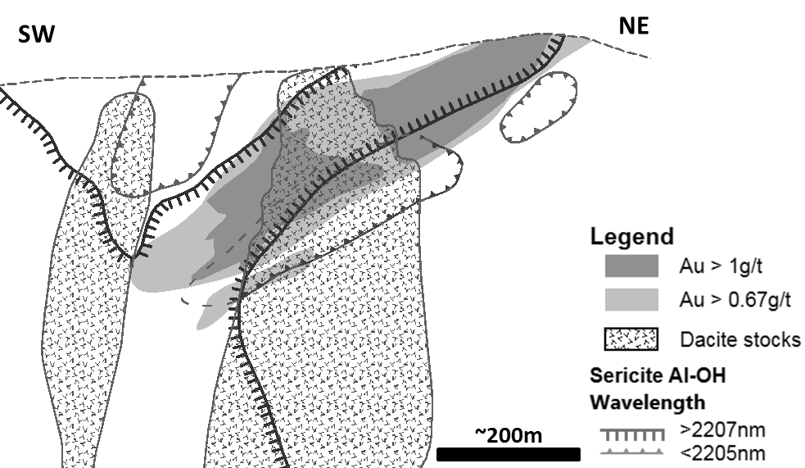****Figure 2:*** *Simplified cross-section through the Mount Rawdon gold deposit looking NE, showing sericite composition contours based on the wavelength of the Al-OH absorption feature relative to gold and pre-mineral dacite stocks. Note that post-mineral dykes have been omitted from this and following diagrams for clarity.*

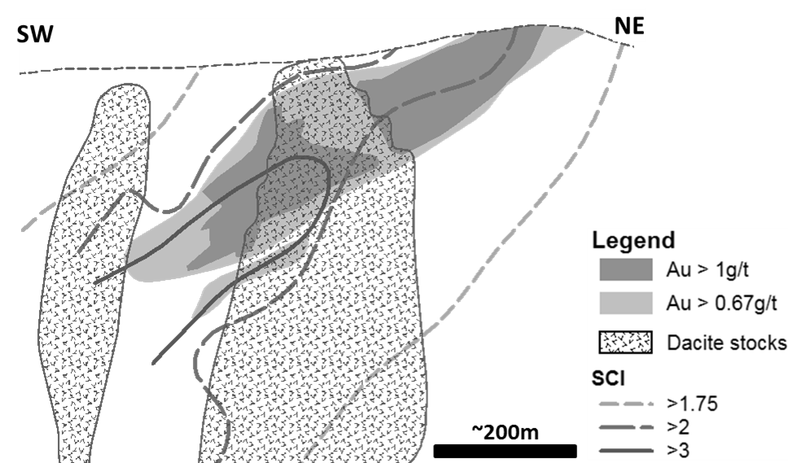

***Figure 3:*** *Simplified cross-section through the Mount Rawdon gold deposit looking NE showing sericite crystallinity index (SCI) contours relative to gold and pre-mineral dacite stocks.*

**Geochemical Zonation**

Multi-element geochemistry using a 4 acid digest ICP-MS/AES analysis suite has been conducted on spaced samples down numerous drill holes through the deposit to help constrain the host geology and understand zonation patterns in pathfinder elements and major element mass changes. These zonation patterns can be used by explorers to both locate and determine the exposure level of similar hydrothermal systems.

Pathfinder element patterns likely reflect the temperature-controlled substitution of trace elements into pyrite and the distribution of base metal sulphides and Bi-Pb-Ag sulphosalt minerals associated with gold (Figure 4; Figure 5).Bismuth shows the closest spatial and statistical relationship to gold and is generally >10 ppm (>50 x background) in association with gold ore. Major element mass changes are variable, and K/Al and Na/Al ratios are commonly similar to least-altered host rocks. However, general patterns in K and Na mass changes can be discerned (Figure 6):

* Deeper parts of the mineralised alteration pipe are defined by K addition and Na removal consistent with moderate to strong sericite alteration and elevated Te, Bi and S (pyrite). A zone of elevated Sb, As, Cu and Se envelopes the deep Bi-Te zone.
* Intermediate levels in the deposit show variable K and Na addition suggesting variable sericite-alkali feldspar alteration and elevated Bi (+ Te, Cu, Ag) in association with gold.
* The upper parts of the deposit show K addition and Na depletion consistent with phengitic sericite ± K-feldspar in addition to elevated Ag, As, Cu, Pb (+ Bi) association with gold. With increasing depth, the zone of high molar K/Al ratios (>0.35) becomes localized on two moderately SW dipping trends near the hanging wall and footwall of the ore zone (Figure 6). These trends are coincident with elevated gold grades and apparent flexures or displacement of the Eastern Dacite contact, suggesting they may represent important fluid flow controlling structures.
* Marginal to the main alteration zone, variable Na addition is suggestive of patchy albite alteration associated with a pathfinder element assemblage of Mn, Zn, Pb and As.



***Figure 4:*** *Schematic chart showing the zonation of pathfinder elements and gold from deep to shallow and marginal positions.*

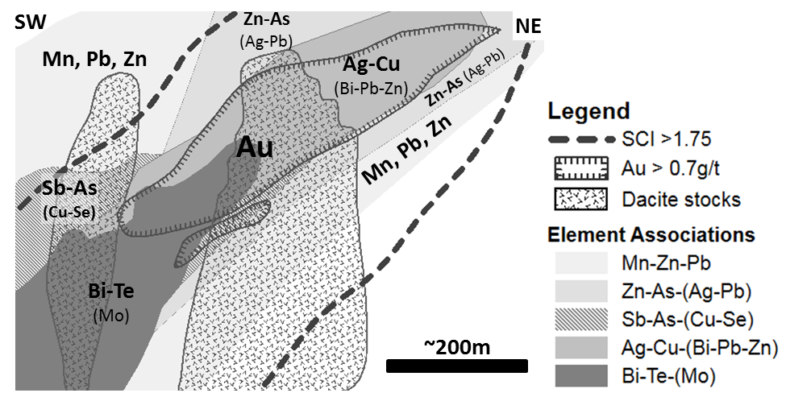

***Figure 5:*** *Simplified cross section through the Mount Rawdon gold deposit looking NE showing the zonation of pathfinder element associations. Element associations were derived using the method of Morrison (pers. comm. 2014), first by determining metal associations from observed spatial associations and correlation coefficients, then adding together log Z-scores of elements in each group before attributing samples by the group with the highest combined log Z-score for a given sample and plotting in a 3D software package.*

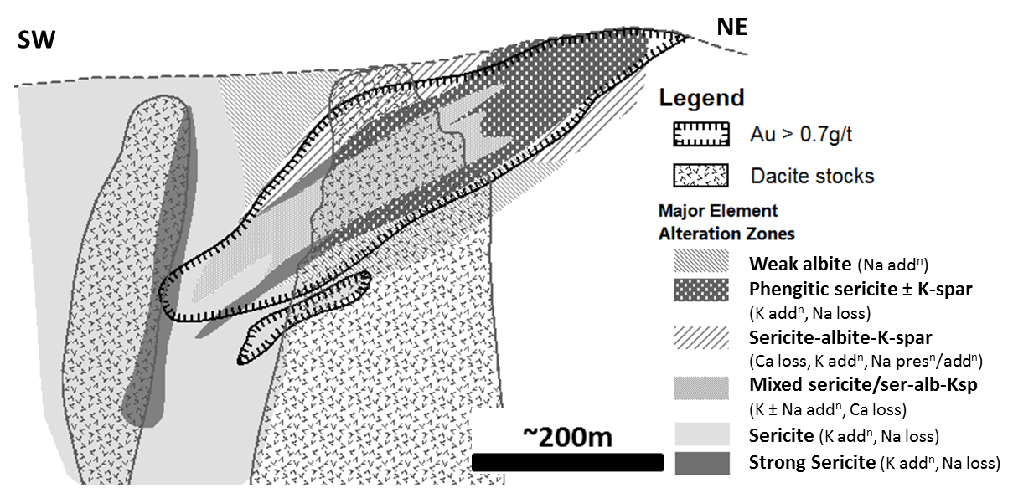

***Figure 6:*** *Simplified cross section through the Mount Rawdon gold deposit looking NE showing the zonation of alteration minerals based on K and Na mass changes. Abbreviations: addn: addition, alb: albite, Ksp/K-spar: K-feldspar, presn: preservation, ser: sericite)*

**Discussion**

Based on the alteration mineral assemblage, mineralisation style, host rock setting and previous fluid inclusion work (Brooker & Jaireth, 1995), Mount Rawdon is interpreted to be an epizonal intrusion-related gold deposit (Figure 7). Sericite crystallinity measurements and observations of the alteration assemblages from this study are consistent with previous fluid inclusion work suggesting the involvement of low to moderate salinity, 250-350oC fluids in formation of the deposit. Changes in the alteration assemblage, sericite crystallinity and pathfinder element zonation all support decreasing temperature as a potential mechanism for gangue, alteration mineral and possibly gold precipitation. Co-existing vapour- and liquid-rich fluid inclusions, the increasingly phengitic nature of sericite, and geochemical evidence for possible K-feldspar in the upper parts of the deposit are all consistent with boiling having taken place and being another potential gold depositional mechanism. The presence of zones of albite on the margins of the deposit, and the generally permeable nature of the host rock also permit fluid mixing between an upwelling fluid with a likely magmatic component and cooler, circulating meteoric waters.

The geochemical and spectral mineral zonation evident at Mount Rawdon suggest that multi-element geochemistry and hyperspectral analysis can be very useful exploration tools, both for vectoring into potentially mineralised hydrothermal systems, and for determining the level of preservation of a hypothetical gold deposit. Explorationists should look for the following patterns to define a preserved Mount Rawdon-style target (i.e. at or just above the top of the gold prospective zone):

* Sericite crystallinity index decreasing outwards from SCI > 1.75.
* Phengitic sericite (Al-OH wavelength > 2210nm) zoned outwards to muscovitic sericite (Al-OH wavelength <2205nm).
* Elevated Ag, Cu, Pb, Zn ± Bi ± Au zoned outwards to As, Zn, Pb, Ag and marginal Mn, Pb, Zn.

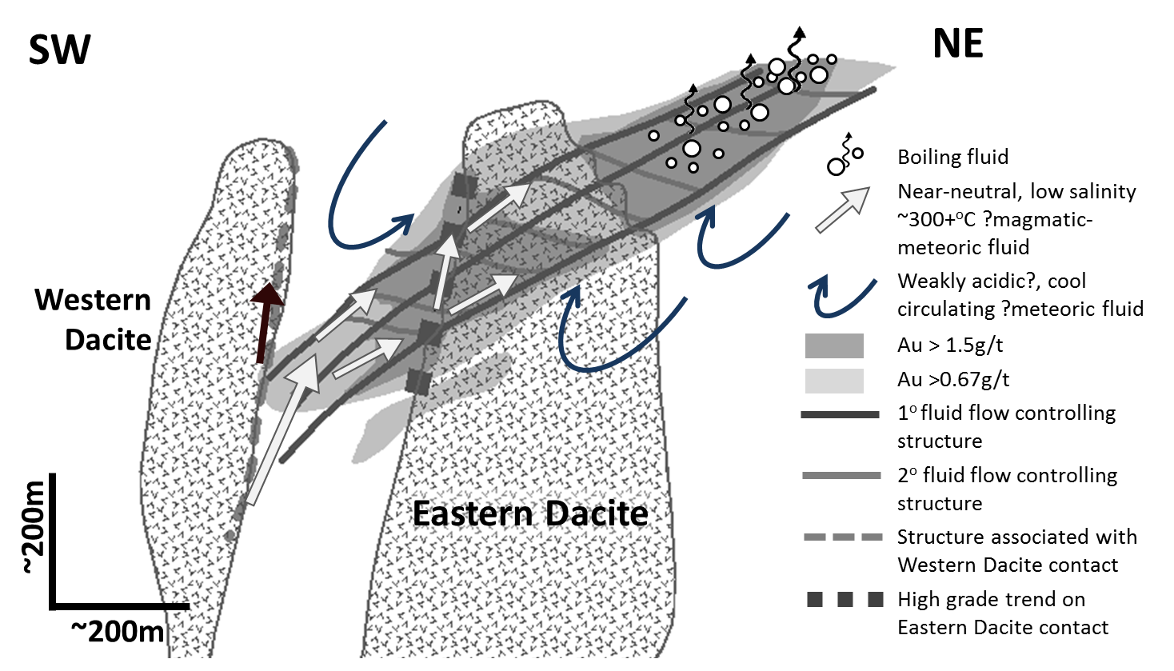

***Figure 7:*** *Schematic cross section through the Mount Rawdon gold deposit showing possible mineralised fluid pathways and depositional mechanisms.*

**References**

Brooker, M., 1991, Geology, alteration and mineralization of the Mount Rawdon diatreme-hosted gold deposit: Unpublished M.Sc. thesis, Townsville, James Cook University, 180 p.

Brooker, M., and Jaireth, S., 1995, Mount Rawdon, Southeast Queensland, Australia; a diatreme-hosted gold-silver deposit: Economic Geology, v.90, pp. 1799-1817.

Cranfield, L.C., and Murray, C.G., 1989, New and revised intrusive units in the Maryborough 1:250,000 sheet area, southeast Queensland: Queensland Government Mining Journal, v.90, pp. 369-378.

Donchak, P.J.T., Purdy, D.J., Withnall, I.W., Blake, P.R. and Jell, P.A., 2013, New England Orogen in Jell, PA., ed., Geology of Queensland: Geological Survey of Queensland, pp. 305-472.

Halley, S., 2007, View from the fringe: Far-field alteration around ore deposits: MDRU/AMEBC Mineral Exploration Roundup 2007 short course, January 2007, Vancouver, Canada.

Harris, A., 2010, Geology of the Mt Rawdon Gold Mine: Newcrest Mining Ltd internal company report, 17 p.

Pontual, S., Merry, N., and Gamson, P., 1997, G-MEX volume 1: Spectral Interpretation Field Manual: AusSpec International Pty Ltd, 169 p.

Scott, K., M., and Yang, K., 1997, Spectral reflectance studies of white micas: AMIRA Project 435 report/CSIRO Exploration and Mining Report 439R, 35 p.

Standing, J., 2014, Outcomes from Pit Mapping at Mt Rawdon Gold Mine, Qld: unpublished report to Evolution Mining Ltd, 22 p.